COS 226 Algorithms and Data Structures Fall 2011

Midterm
This test has 9 questions worth a total of 60 points. You have 80 minutes. The exam is closed book, except that you are allowed to use a one page cheatsheet. No calculators or other electronic devices are permitted. Give your answers and show your work in the space provided. Write out and sign the Honor Code pledge before turning in the test.
“I pledge my honor that I have not violated the Honor Code during this examination.”
Problem | Score | Problem | Score | Name:
0 |  | 5
1 |  | 6 |  | Login ID:
2 |  | 7
3 |  | 8 |  | Precept:
4 |  |  |  |  | P01 | 11 | Maia Ginsburg
Sub 1 |  | Sub 2 |  |  | P01A | 11 | Aman Dhesi
 |  |  |  |  | P02 | 12:30 | Sasha Koruga
Total |  |  |  |  | P02A | 12:30 | Joey Dodds
 |  |  |  |  | P03 | 1:30 | Maia Ginsburg
 |  |  |  |  | P03A | 1:30 | Joey Dodds

1
0. Miscellaneous. (1 point)
In the space provided on the front of the exam, write your name and Princeton NetID; circle your precept number; and write and sign the honor code.
1. Union ﬁnd. (6 points)
Circle the letters corresponding to arrays that cannot possibly occur during the execution of weighted quick union.
i: 0 1 2 3 4 5 6 7 8 9
A. a[i]:1230111445
B. a[i]:9000009999
C. a[i]:1234567899
D. a[i]:0000011162
E. a[i]:0000011168
F. a[i]:0001133777
2. Analysis of algorithms. (6 points) Suppose that you collect the following timing data for a program as a function of the input
size N.
N
125 | 0.03 sec
1,000 | 1.00 sec
8,000 | 32.00 sec
64,000 | 1,024.00 sec
512,000 | 32,768.00 sec

time
Estimate the running time of the program (in seconds) as a function of N and use tilde notation to simplify your answer. Hint: recall that logb a = lg a/ lg b.
3. Data structures. (9 points)
Suppose that the Java library java.util.LinkedList is implemented using a doubly-linked list, maintaining a reference to the ﬁrst and last node in the list, along with its size.
public class LinkedList<Item> { private Node first; // the first node in the linked list private Node last; // the last node in the linked list private int N; // number of items in the linked list
private |  | class |  |  |  |  | Node |  |  | {
 | private |  |  | Item |  |  |  | item; // the item
 | private |  |  |  | Node |  |  |  | next, prev; |  | // | the | next | and previous nodes
}
...
}

(a) Using the 64-bit memory cost model from the textbook, how much memory (in bytes) does a Node object use and how much does a LinkedList object use to store N items? Do not include the memory for the items themselves but do include the memory for the references to them.
    - Memory of a Node:
    - Memory of a LinkedList with N items:
    - (b) What is the order of growth of the worst-case running time of each of operation below? Write down the best answer in the space provided, using one of the following possibilities.

√
1 log N NNN log NN2
addFirst(item) | prepend the item to the beginning of the list
get(i) | return the item at position i in the list
set(i, item) | replace position i in the list with the item
removeLast() | delete and return the item at the end of the list
contains(item) | is the item in the list?

4. 8 sorting and shuﬄing algorithms. (8 points) The column on the left is the original input of strings to be sorted or shuﬄed; the column on the right are the string in sorted order; the other columns are the contents at some
intermediate step during one of the 8 algorithms listed below. Match up each algorithm by writing its number under the corresponding column. Use each number exactly once.
navy | coal | corn | blue | blue | blue | wine | bark | mist | bark
plum | jade | mist | gray | coal | coal | teal | blue | coal | blue
coal | navy | coal | rose | gray | corn | silk | cafe | jade | cafe
jade | plum | jade | mint | jade | gray | plum | coal | blue | coal
blue | blue | blue | lime | lime | jade | sage | corn | cafe | corn
pink | gray | cafe | navy | mint | lime | pink | dusk | herb | dusk
rose | pink | herb | jade | navy | mint | rose | gray | gray | gray
gray | rose | gray | teal | pink | navy | jade | herb | leaf | herb
teal | lime | leaf | coal | plum | pink | navy | jade | dusk | jade
ruby | mint | dusk | ruby | rose | plum | ruby | leaf | mint | leaf
mint | ruby | mint | plum | ruby | rose | pine | lime | lime | lime
lime | teal | lime | pink | teal | ruby | palm | mint | bark | mint
silk | bark | bark | silk | bark | silk | coal | silk | corn | mist
corn | corn | navy | corn | corn | teal | corn | plum | navy | navy
bark | silk | silk | bark | dusk | bark | bark | navy | wine | palm
wine | wine | wine | wine | leaf | wine | gray | wine | silk | pine
dusk | dusk | ruby | dusk | silk | dusk | dusk | pink | ruby | pink
leaf | herb | teal | leaf | wine | leaf | leaf | ruby | teal | plum
herb | leaf | rose | herb | cafe | herb | herb | rose | sage | rose
sage | sage | sage | sage | herb | sage | blue | sage | rose | ruby
cafe | cafe | pink | cafe | mist | cafe | cafe | teal | pink | sage
mist | mist | plum | mist | palm | mist | mist | mist | pine | silk
pine | palm | pine | pine | pine | pine | mint | pine | palm | teal
palm | pine | palm | palm | sage | palm | lime | palm | plum | wine
--- | --- | --- | --- | --- | --- | --- | --- | --- | ---
0 |  |  |  |  |  |  |  |  | 1

(0) Original input
(1) Sorted
(2) Selection sort
(3) Insertion sort

(4) Mergesort (top-down)
(5) Mergesort (bottom-up)

(6) Quicksort (standard, no shuﬄe)
(7) Quicksort (3-way, no shuﬄe)
(8) Heapsort
(9) Knuth shuﬄe

5. Binary heaps. (6 points)
(a) Consider the following binary tree representation of a max-heap.
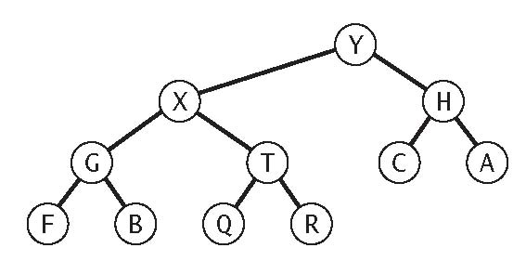
Give the array representation of the heap.
0 | 1 | 2 | 3 | 4 | 5 | 6 | 7 | 8 | 9 | 10 | 11 | 12
- |  |  |  |  |  |  |  |  |  |  |  | -

(b) Insert the key P into the binary heap above, circling any entries that changed.
(c) Adelete-the-max operation in the binary heap at left results in the binary heap at right.

0 | 1 | 2 | 3 | 4 | 5 | 6 | 7 | 8 | 9 | 10 | 11 | 12
-

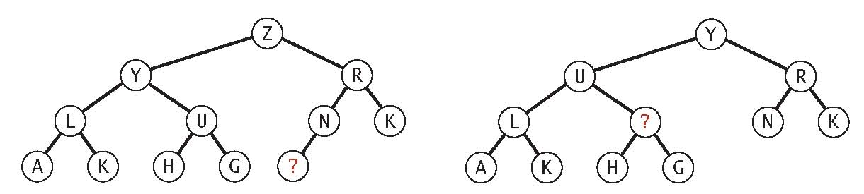
Which of the keys below could be the one labeled with a question mark? Circle all possibilities.
ABCDEFGHIJKLMNOPQRSTUVWXYZ
6. Red-black BSTs. (8 points)
Consider the following left-leaning red-black BST. Some of the colors and key values are suppressed.
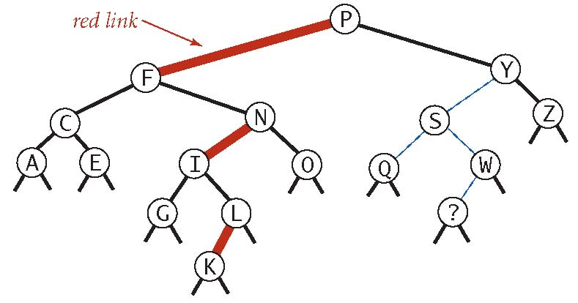
(a) Which of the keys below could be the one labeled with a question mark? Circle all possibilities.
ABCDEFGHIJKLMNOPQRSTUVWXYZ
(b) For each link from the left-hand column, select its possible color(s) from the right-hand column.
−−−− link between W and S A. red −−−− link between ? and W B. black −−−− link between S and Y C. either red or black −−−− link between Q and S
(c) How many left rotation, right rotation, and color ﬂip operations would be used to insert each key below into the original red-black BST above?
 | H | D | B | J
rotateLeft() | 1
rotateRight() | 0
flipColors() | 0

7. Comparing two arrays of points. (8 points) Given two arrays a[] and b[], each containing N distinct points in the plane, design two
algorithms (with the performance requirements speciﬁed below) to determine whether the two arrays contains precisely the same set of points (but possibly in a diﬀerent order).
For each algorithm, give a crisp and concise English description of your algorithm. Your answer will be graded on correctness, eﬃciency, and clarity.
(a) Design an algorithm for the problem whose running time is linearithmic in the worst case and uses at most constant extra space.
(b) Design an algorithm for the problem whose running time is linear under reasonable assumptions and uses at most linear extra space. Be sure to state any assumptions that you make.

8. Stabbing count queries. (8 points) Given a collection of x-intervals and a real value x,a stabbing count query is the number of
intervals that contain x. Design a data structure that supports interval insertions intermixed with stabbing count queries by implementing the following API:
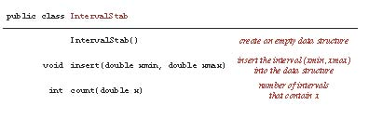
For example, after inserting the ﬁve intervals (3, 10), (4, 5), (6, 12), (8, 15), and (19, 30) into the data structure, count(9.1) is 3 and count(17.2) is 0.
If there are N intervals in the data structure, you should support insert and count in time
proportional to log N in the worst case (even if count() returns N). For simplicity, assume that no two intervals contain a left or right endpoint in common and that the argument to the stabbing count query is not equal to a left or right endpoint.
Give a crisp and concise English description of your data structure. Your answer will be graded on correctness, eﬃciency, and clarity.
- IntervalStab():
- insert(xmin, xmax):
- count(x):

